**CHAPTER 3**

**SOFTWARE MODELING**

**3.1. ER Diagram**

Fundamentally, the ER Diagram is a structural design of the database. It acts as a framework created with specialized symbols for the purpose of defining the relationship between the database entities. ER diagrams or ERD's are composed of three main elements: entities, attributes, and relationships.

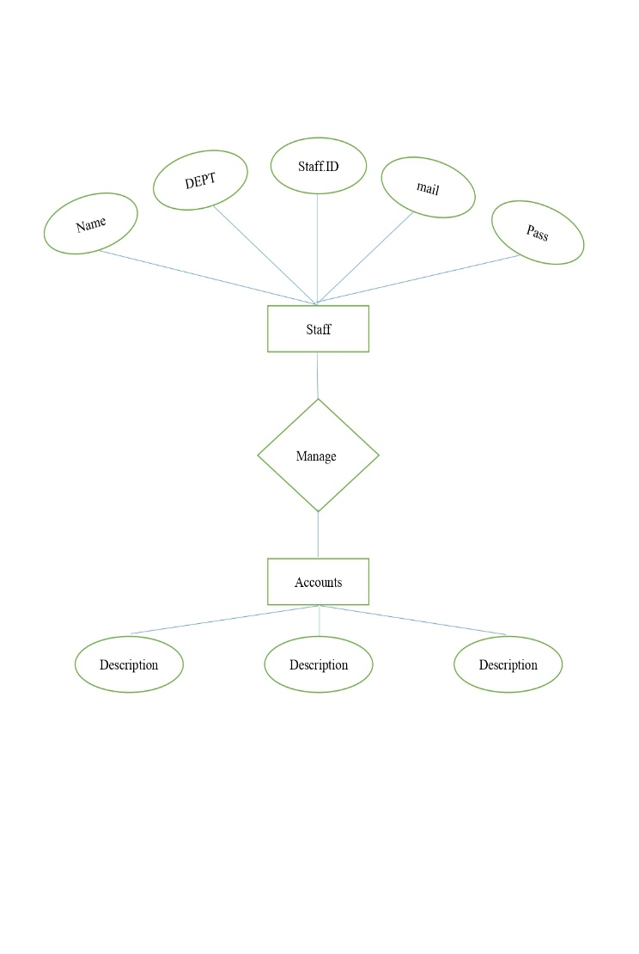

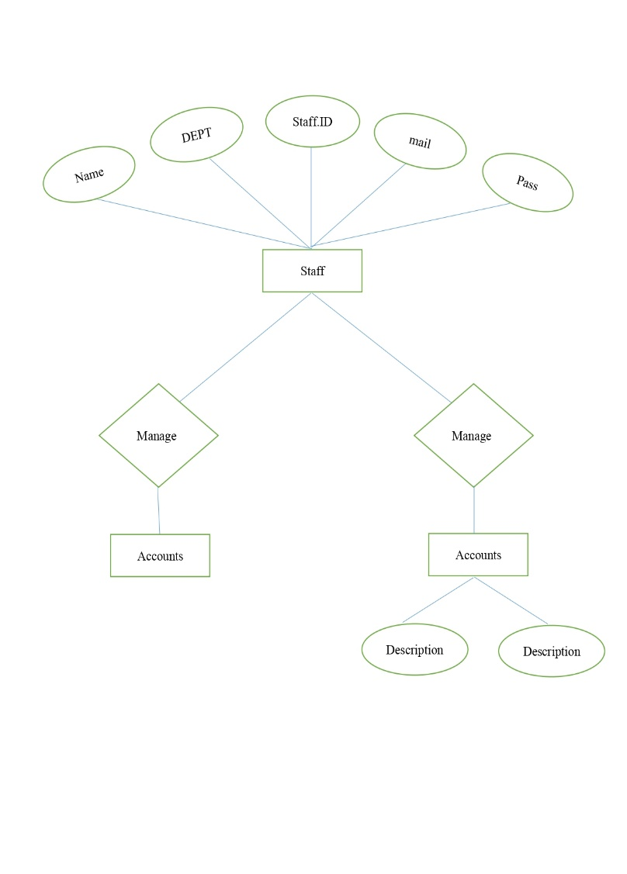

**Data Flow Diagram**

A two-dimensional diagram explains how data is processed and transferred in a system. The graphical depiction identifies each source of data and how it interacts with other data sources to reach a common output. Individuals seeking to draft a data flow diagram must identify external inputs and outputs, determine how the inputs and outputs relate to each other, and explain with graphics how these connections relate and what they result in. This type of diagram helps business development and design teams visualize how data is processed and identify or improve certain aspects.

**LEVEL 0:**

DFD Level 0 is also called a Context Diagram. It’s a basic overview of the whole system or process being analyzed or modeled. It’s designed to be an at-a-glance view, showing the system as a single high-level process, with its relationship to external entities. It should be easily understood by a wide audience, including stakeholders, business analysts, data analysts and developers**.**

Staff

Database

Student

**Level 2**

The level 1 shows out the exact identification of the multiple sub level flow from one option system.

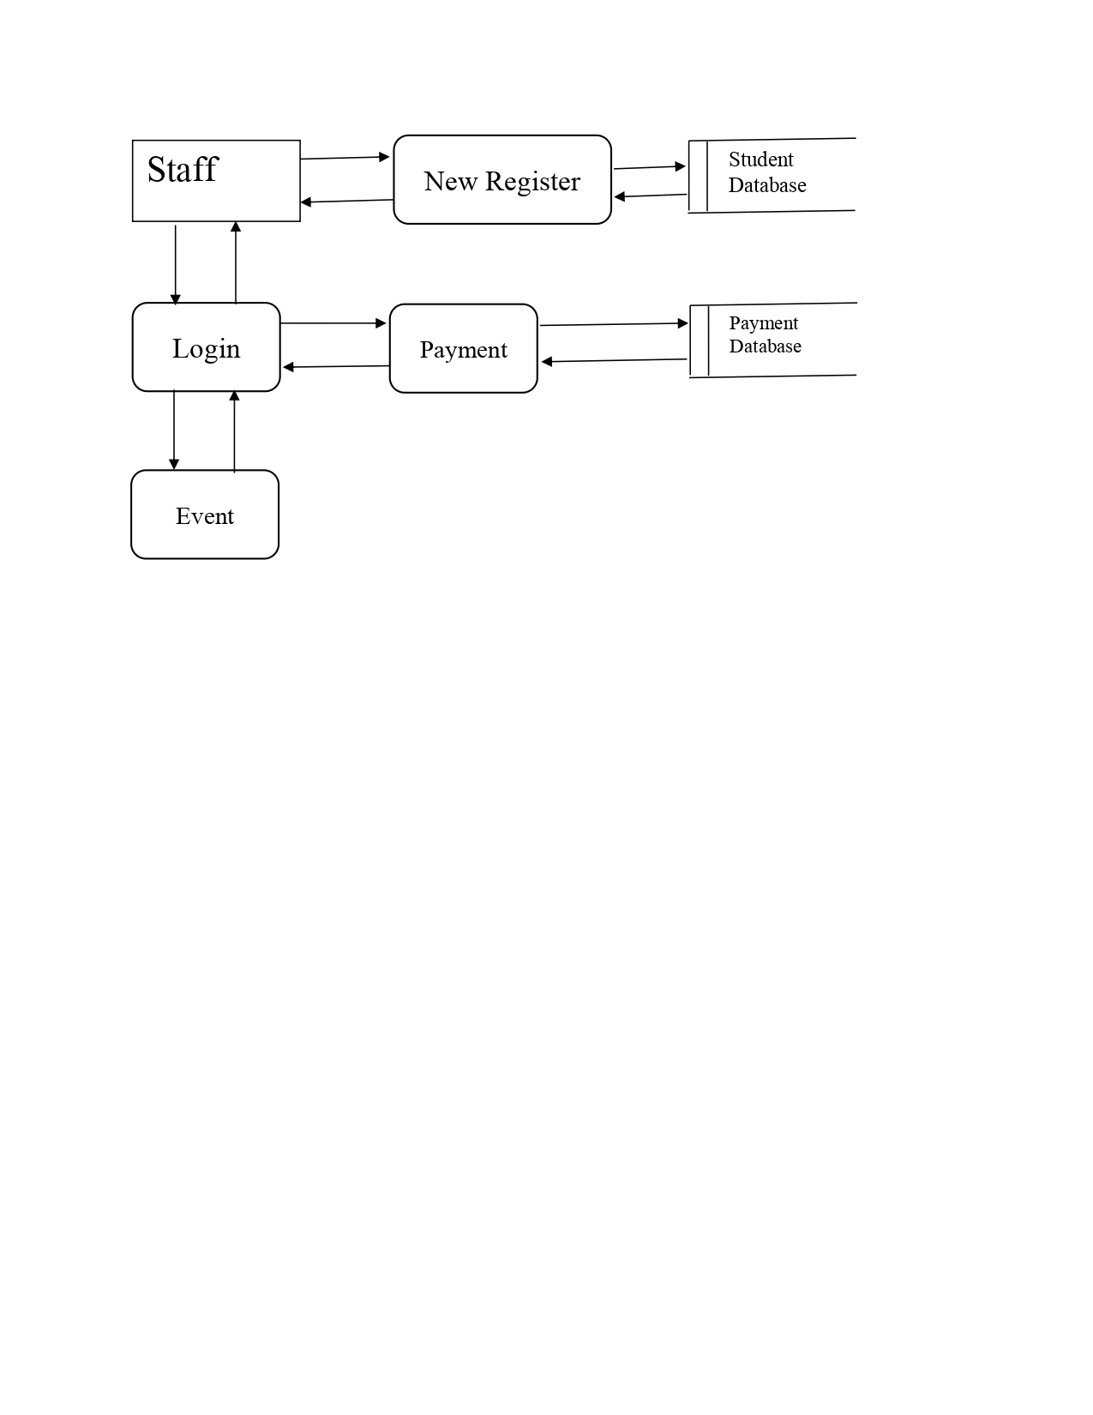

**Level 2**

The level 2 diagram gives multi access storage system with the current data access and generations.

